3rd Quarter Extra Credit Project Student:_______________________

Choices:
⃞Ben Frankin report poster
⃞William Penn report poster
⃞Salem Witch Trials report poster
⃞ Colony recreation* model diorama
*must have a key

Accuracy ___/4
Neatness/Effort ____/2
Total Extra Credit points ____/6

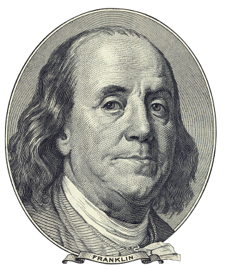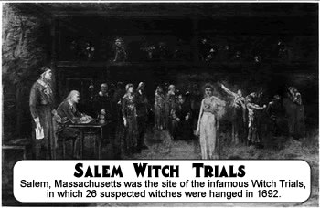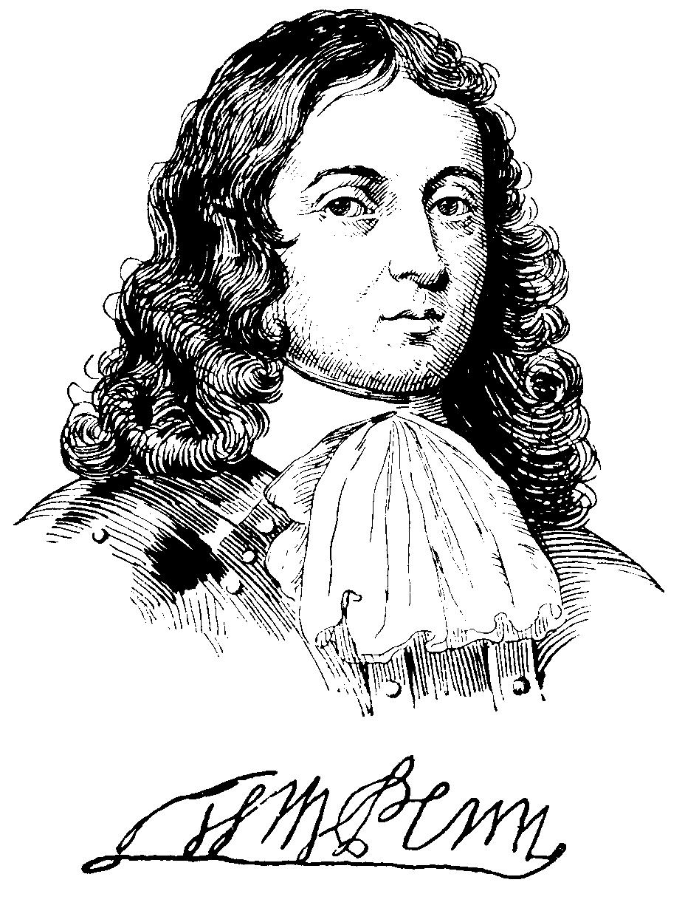

3rd Quarter Extra Credit Project Student:_______________________

Choices:
⃞Ben Frankin report poster
⃞William Penn report poster
⃞Salem Witch Trials report poster
⃞ Colony recreation* model diorama
*must have a key

Accuracy ___/4
Neatness/Effort ____/2
Total Extra Credit points ____/6

